**Institute of Technology Tralee**

**Ord/Hons BSc. in Computing with Specialism (Group B) - Year 1**

**Continuous Assessment #2**

**Date: 6/12/12**

**Time: 3 – 5 p.m.**

**Introduction to Programming**

**Instructions:** Attempt the following question. You should use the JCreator IDE for coding. When you are finished you must print out your code for correction.

**________________________________________________________**

**Q1. (Contains modifications to original question)**

A Java program is required that will read in a web address and validate it. In this simplified case we will assume that a valid web address has the following structure:

www.**********.com

Here the stars represent any combination of letters (upper or lowercase) and digits and we will assume that all other characters such as dashes and question marks are invalid here.

We will also assume that there can be a **maximum of 30 characters** and a **minimum of 1 character** between the “www.” and the “.com” – meaning that valid web address must have between 9 and 38 characters inclusive. Your first test will be to ensure this is the case. If it is, then further validation will occur, otherwise an appropriate error message will be issued.

If it passes the first test, the web address entered should then be checked to see if it begins with “www.” If it doesn’t, an appropriate error message should be given. Otherwise, the program should proceed with the next part of the validation, which is to check the middle part of the web address.

If the first 2 parts of the web address are valid, finally the web address should be checked to see if it ends with “.com”. Again, an appropriate error message will be issued if it fails this test.

Note that there will be a few marks awarded for having a **single-line comment** and a **meaningful multi-line comment at the top of the program**.

Your program should run as indicated in the following screenshots and include any banners, blank lines, tabs etc. as appropriate:

**Sample Screen Shots**

**In this run the web address contains too few characters**

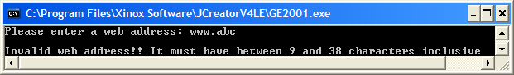

**In this run the web address contains too many characters**

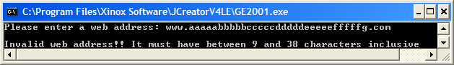

**In this run the web address does not begin with www.**

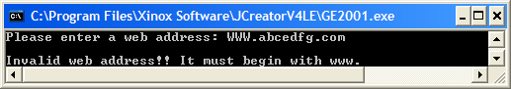

**In this run one of the characters in the middle part of the web address is invalid**

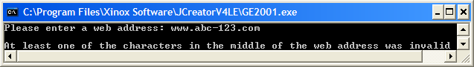

**In this run the web address does not end with .com**

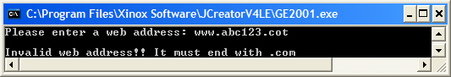

**In this run the web address is valid**

